**Capture The Criminal**

**Task:**

After getting Kory's location, there's only one thing left to do. Capture him and bring him back to the headquarter. You positioned  agents C:/Users/Kory/AppData/Local/Temp/wps.pUfDbWwps. The agents at and C:/Users/Kory/AppData/Local/Temp/wps.NineyJwpsare adjacents to each other as well as the agents at 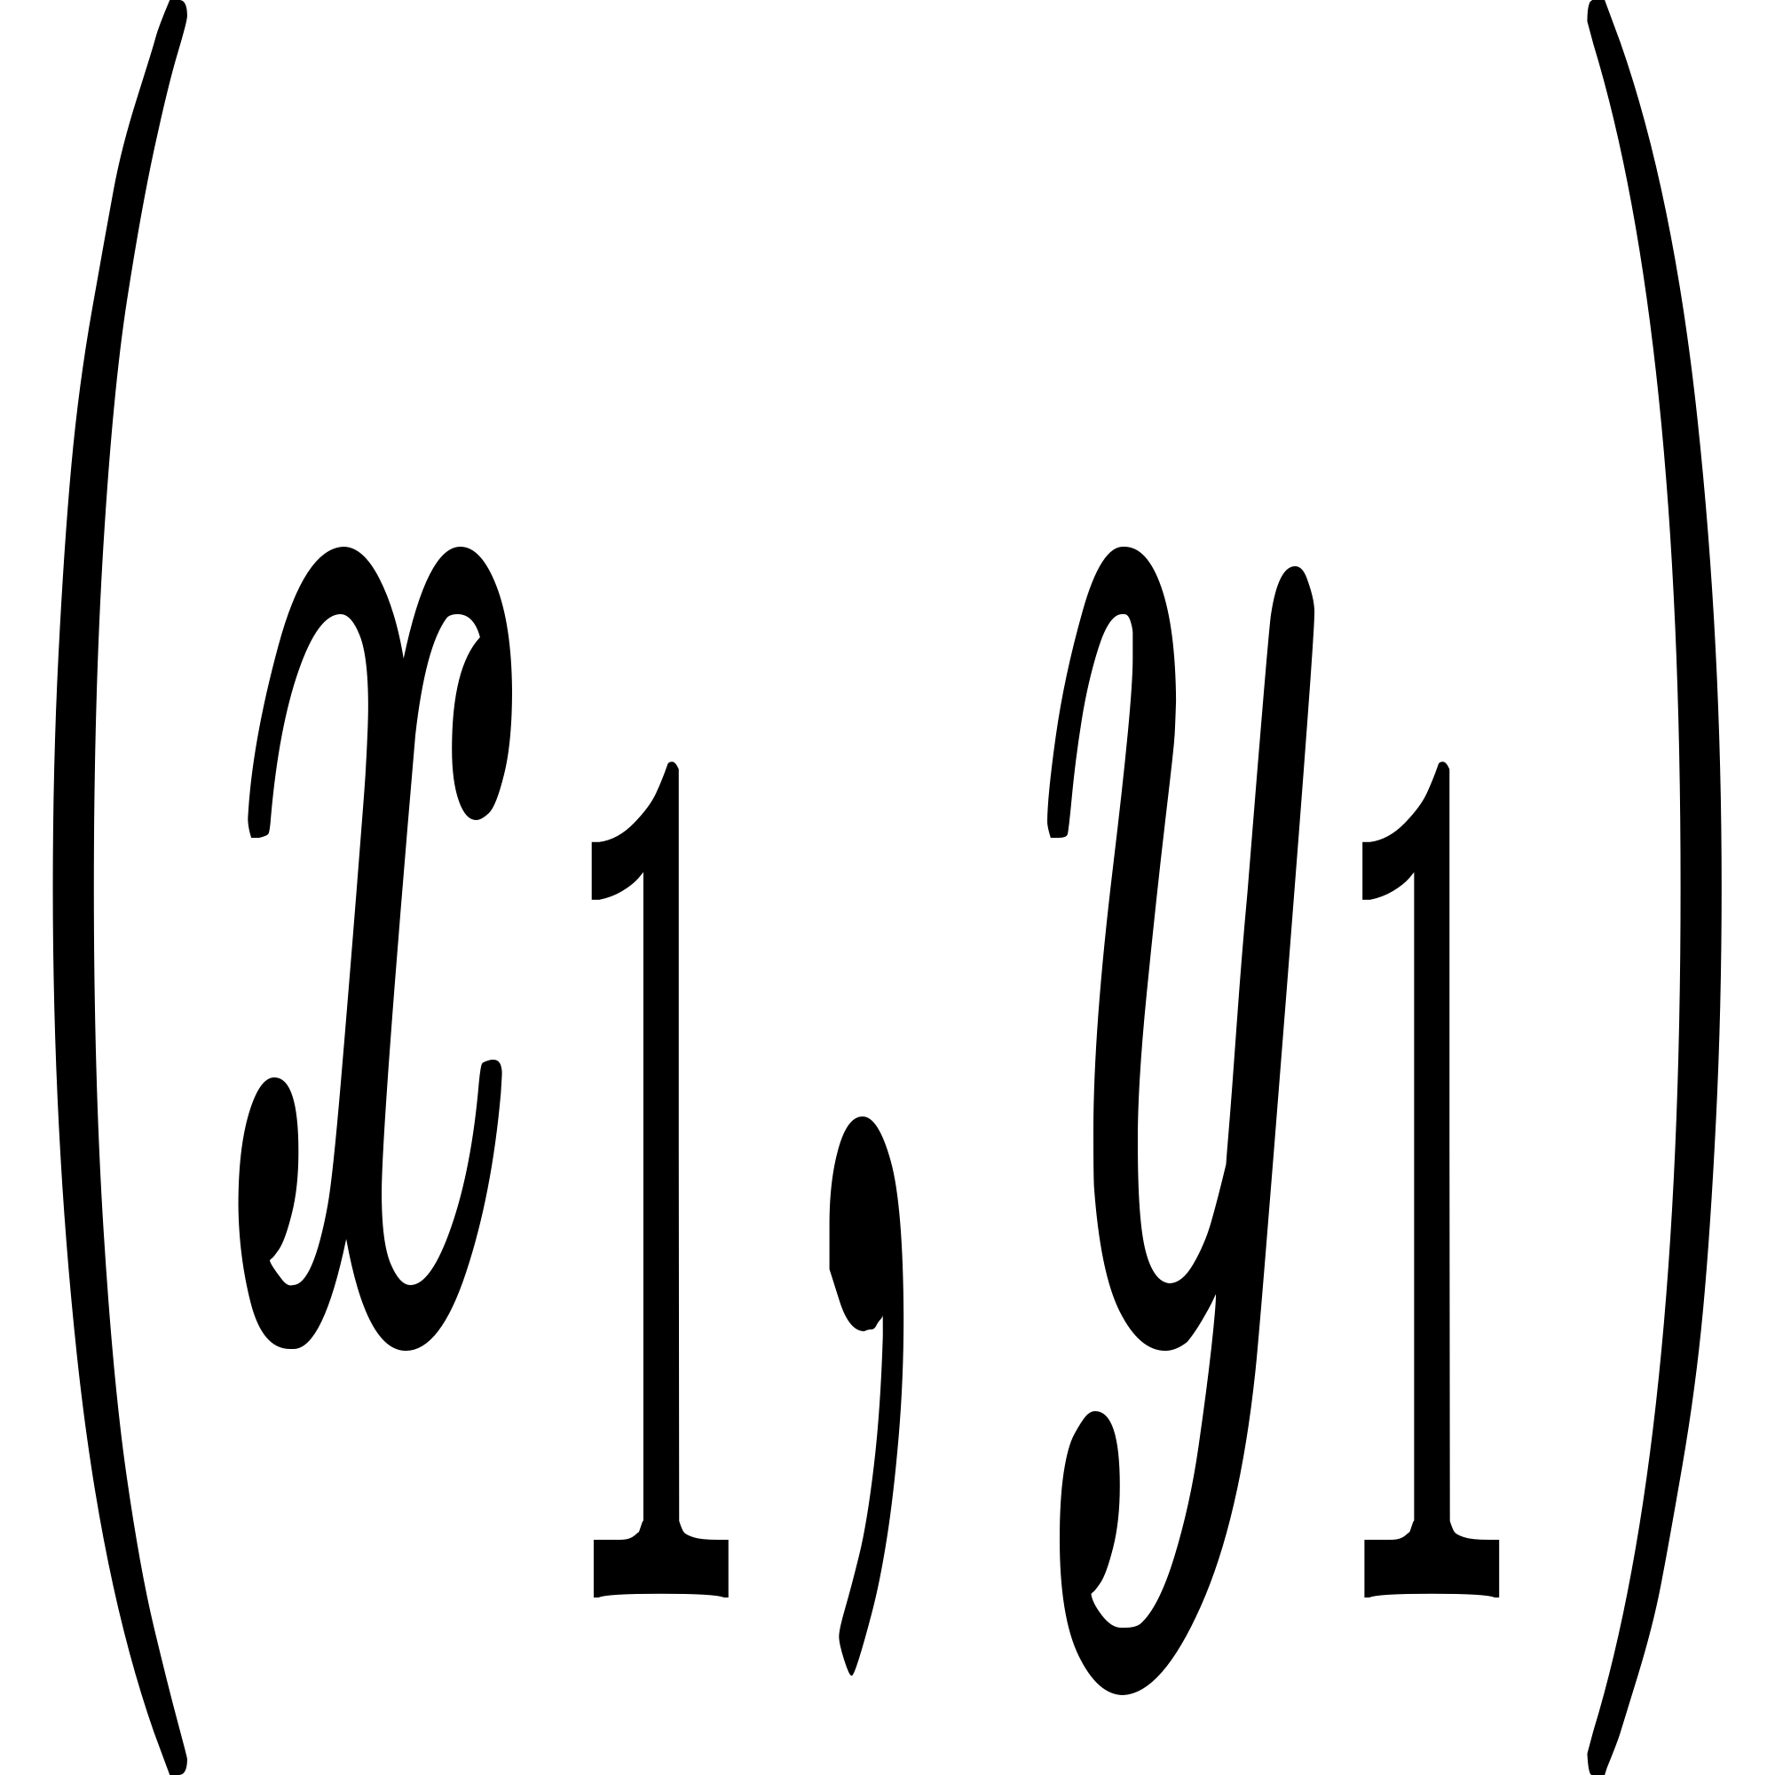and C:/Users/Kory/AppData/Local/Temp/wps.ZdrIggwps which then makes a polygon of n vertices.

Kory can be at  locations and you need to determine for each location if it is inside, outside or on the boundary of the polygon.

**Input:**

The first input line has two integers  and  : the number of agents and the amount of locations.

After this, there are  lines that describe the agents locations. The i-th such line has two integers .

You may assume that the polygon is simple, i.e., it does not intersect itself.

Finally, there are  lines that describe the points. Each line has two integers  and wps .

**Output:**

For each point, print "INSIDE", "OUTSIDE" or "BOUNDARY".

**Sample**

|  |  |
| --- | --- |
| Input | Output |
| 4 3  1 1  4 2  3 5  1 4  2 3  3 1  1 3 | INSIDE  OUTSIDE  BOUNDARY |